



Pre-employment declaration form

|  |  |
| --- | --- |
| Applicant Name (As per Aadhar card): | Asadmadni Mohammed Islam Shaikh |
| First Name: | Asadmadni |
| Last Name: | Shaikh |
| Date of Joining (Proposed) | **-** |
| Location: | **Mumbai** |

**Personal Particulars**

|  |  |
| --- | --- |
| Gender | Male |
| Date of Birth (DD-MM-YYYY) | 06-05-1996 |
| Age | 28 |

**Address**

|  |  |
| --- | --- |
| Present:  (Please add landmark and pin code as compulsory information) | 304, Building No. 1, Aman Apartment, Lady Ratan CHS, Dainik Shivner Road, Worli, Mumbai – 400018  Landmark: Opposite Municipal Industrial Estate |
| Permanent:  (Please add landmark and pin code as compulsory information) | Same as Above |

**Contact details**

|  |  |
| --- | --- |
| Mobile No. | 9867171190 |
| Email Address | Shaikhasad7@gmail.com |

**Education/Professional Qualification**

|  |  |  |  |  |  |  |
| --- | --- | --- | --- | --- | --- | --- |
| **University/College/School** | **Date (mm/yy)** | | **Area/subject of Specialization** | **Degree Awarded** | **% of marks obtained** | **Seat No** |
| **From** | **To** |  |  |  |  |
| PG |  |  |  |  |  |  |
| UG | 2014 | 2017 | Information Technology | Bachelor of Engineering | 7.05 CGPI | 51286660 |

**Total Work Experience/Employment History:**

(Pls include the details for your current employer along with rest of the previous employers)

|  |  |  |  |  |  |  |  |
| --- | --- | --- | --- | --- | --- | --- | --- |
| **Company Name & Full Address** | **Period (dd/mm/yy)** | | **Last Position Held** | **Last Salary** | **Reason of Leaving** | **Employee Code** | **Supervisor’s Name, email id, & contact number** |
| **From** | **To** |
|  | 2022 | - | Senior Associate | 21.5 LPA | Looking for better opportunity and growth | 13407 |  |
|  | 2019 | 2022 | Software Engineer | 10.8 LPA |  |  |  |
|  | 2017 | 2019 | Software Consultant | 5.1 LPA |  |  |  |

**ID Proof Details:**

|  |  |
| --- | --- |
| PAN No. | HFSPS4782B |
| Aadhar No. | 884526347650 |
| Passport No. | U4226681 |

Note: Pls note that our background verification partner i.e HireRight, will contact you to collect the details & documents for background verification purposes. We expect you to submit the required details within 2 working days of receiving the applicant screening form from the HireRight team. Any failure to submit the required details within the timeline would entail revoking of offer by the company.

I hereby state that all the information provided above is true and I consent and authorize the company, either directly or through its third part vendors, to review and verify all details and documents submitted and investigate all the statements contained hereinabove. If any part of the above information is found to be incorrect or incomplete, the company can take disciplinary action including revoking of the offer of employment or dismissal/termination from employment.

Thanks & Regards,

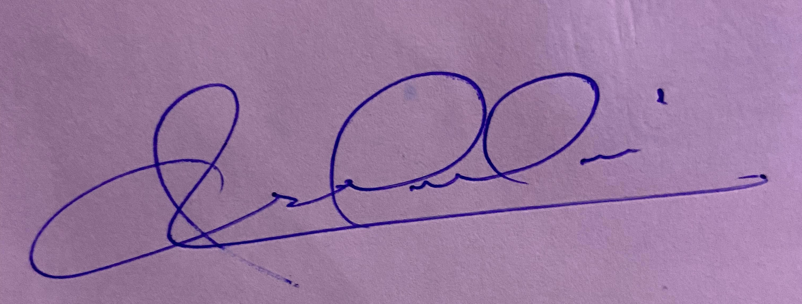

Asadmadni Shaikh

(Name & Signature of the employee